NAME ______________________________________________________________ SECTION: ______________

PROJECT: MIRROR MASK PHOTOGRAPHY DATE:__________________

ARTISTIC SKILLS /70 POINTS
Reflect on your finished work to see if you understood and demonstrated the evaluation standards by rating yourself.

Not at all Some Always EVALUATION STANDARDS

0 2 4 6 8 10 Photos follow guidelines and clearly communicate the topic of your
project option
0 2 4 6 8 10 Photos were taken with good composition (lighting, focus, rule of 3rds,
subject size, perspective, foreground/middle ground/background)
0 2 4 6 8 10 Photos were taken with creativity (see different by changing size,
view, or angle of an object)
0 2 4 6 8 10 Your project follows all directions provided in the handout

0 2 4 6 8 10 Your project communicates the topic of your project

0 2 4 6 8 10 In creating your project you stretched yourself and used creativity

0 2 4 6 8 10 Your project was created with good craftsmanship

ARTISTIC KNOWLEDGE /23 POINTS
Write your answer in a short phrase.

/3 What is photography?

/6 What are the three kinds of cameras?

/4 What are the two different kinds of light?

/4 Draw the lines where the subject should be if you were following the Rule of 3rds.

/6 Label the foreground, middle ground, and background in Fiorella’s picture.

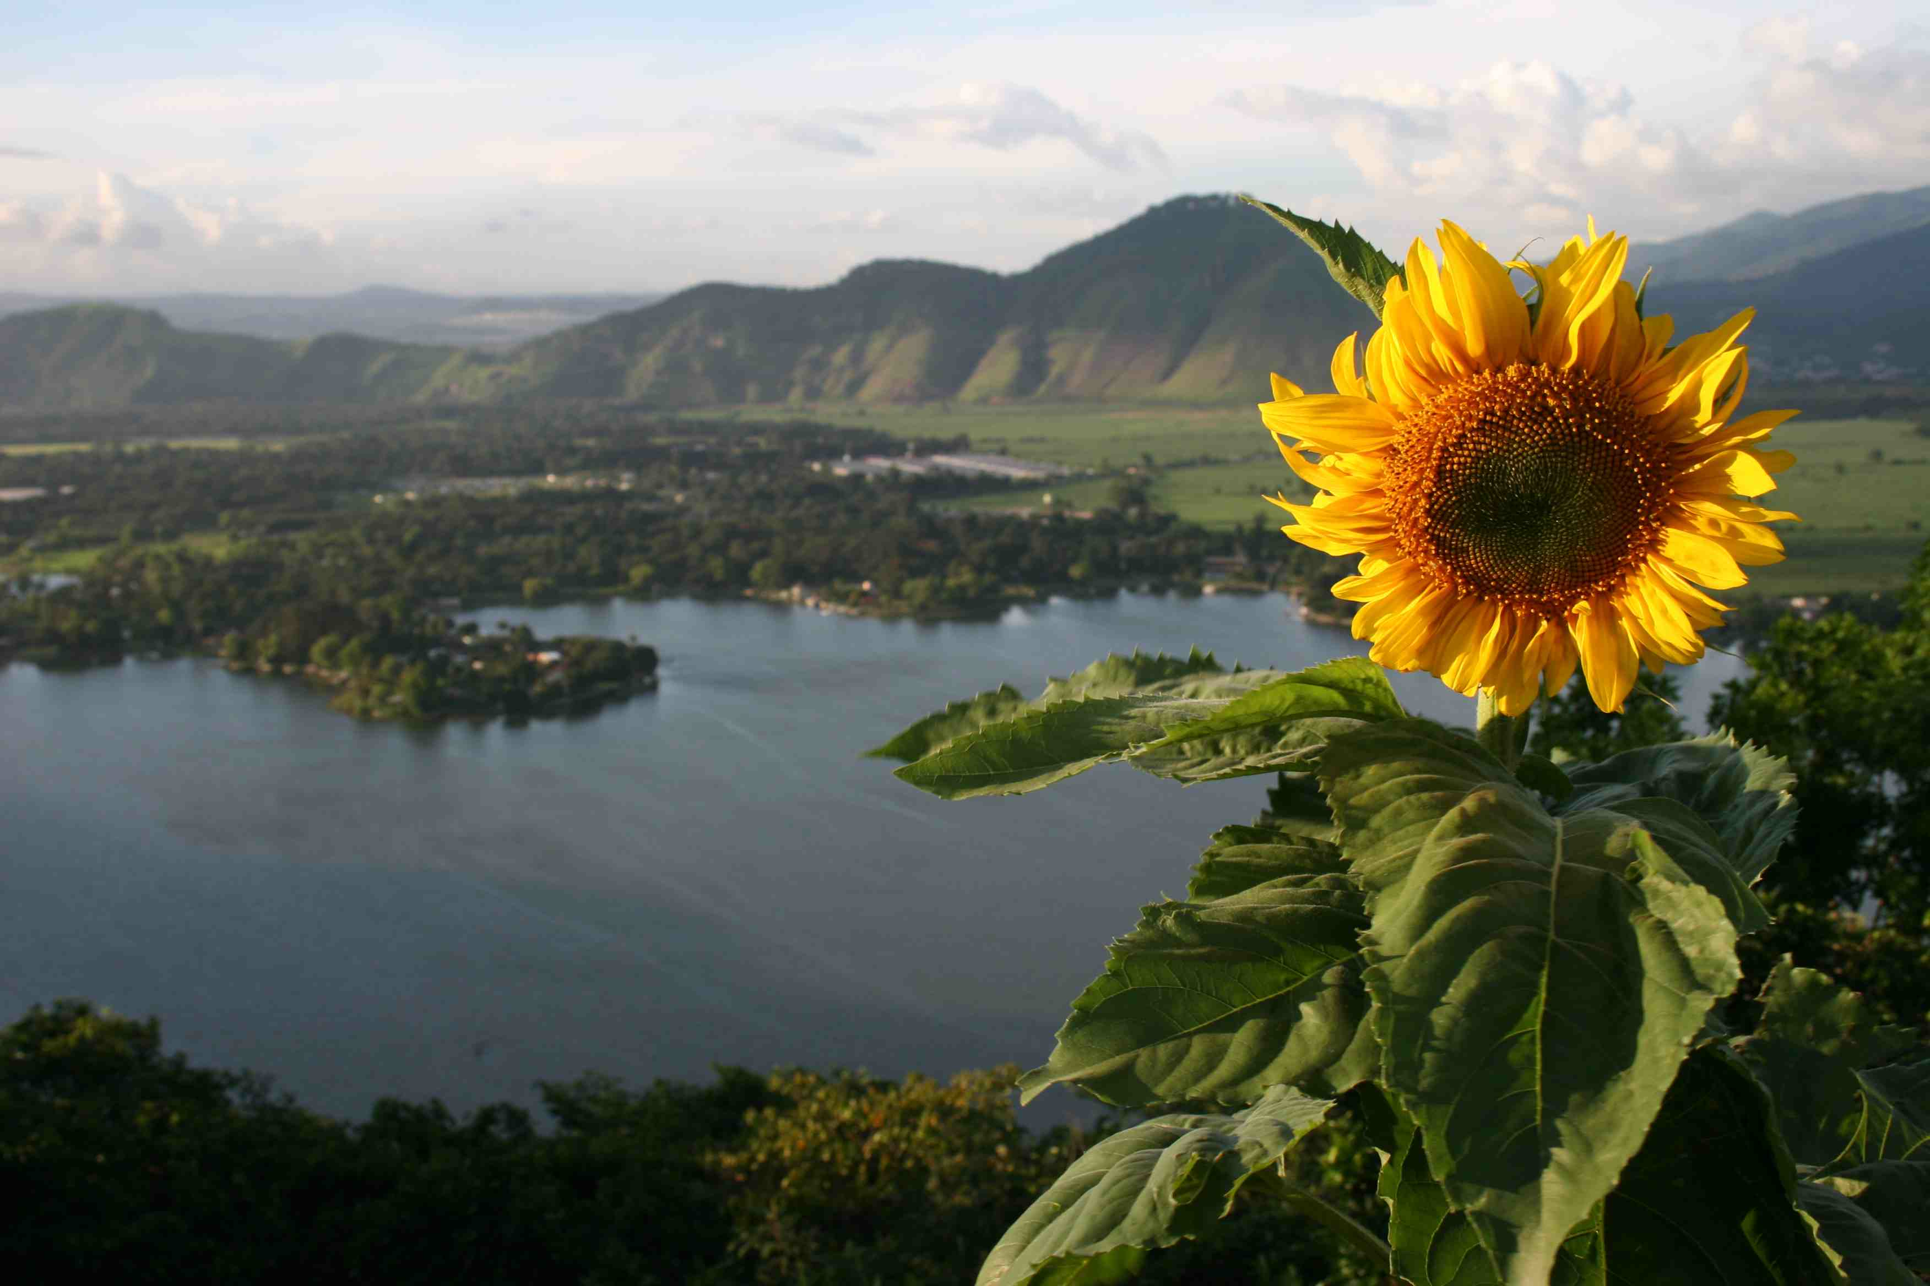
WRITTEN REFLECTION /70 POINTS
In your writing, did you follow the directions and reflect on your life and the world?

/10 Follow directions: 1 page, double spaced, size 12 Times New Roman font
/40 You answered each question in depth with thought and reflection.
/10 You used complete sentences that formed organized paragraphs.
/10 Your paper shows professionalism with proper punctuation and grammar.

This is not graded, but I want you to reflect on yourself . . .
Rate yourself in effort in this project: 0 1 2 3 4 5
Rate yourself in responsibility in this project: 0 1 2 3 4 5

Is there anything else you want to share with me?
______________________________________________________________________________
______________________________________________________________________________
______________________________________________________________________________
_______________________________________________________________________________________

TOTAL POINTS EARNED

Artistic Skills ________/70

Artistic Knowledge ________/23

Written Reflection ________/70

Current 4th Quarter Grade:_________

